1G / PENTHOUSE COLLECTION

T H E

MILL

ONE BEDROOM

SUITE: 849 SQ.FT.

FLOORS

19 THROUGH 20


 | EP | W/D
 |  | KITCHEN
 |  | 15'-6" X 11'-9"
11'-10" |  | 8'-2"
BEDROOM | 12'-10" | DINING
12'-8" X 12'-10"
LIVING
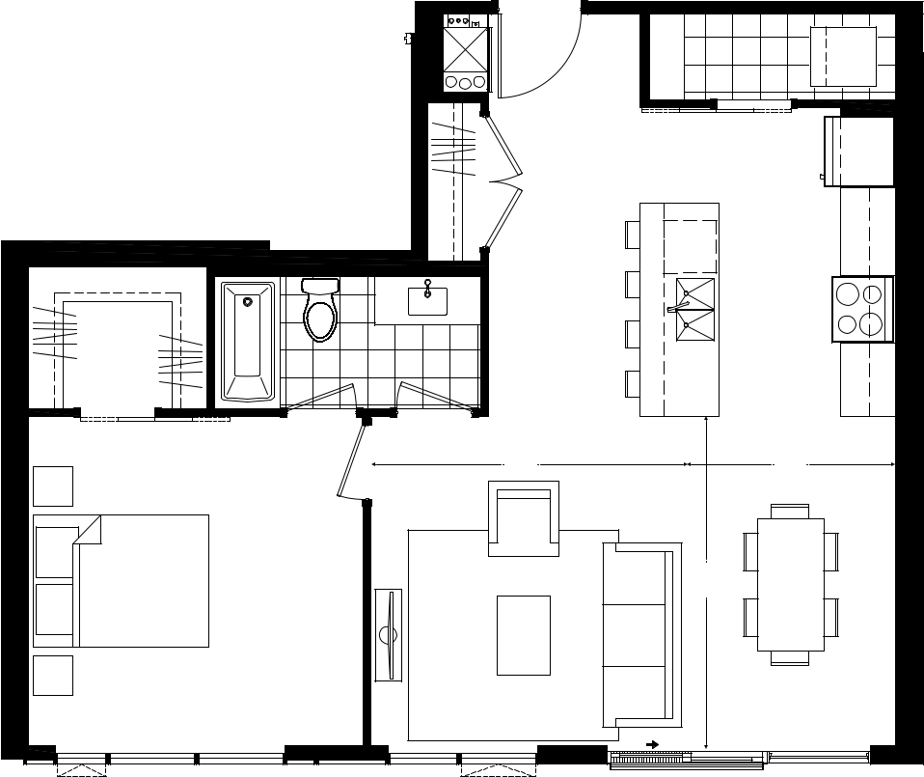
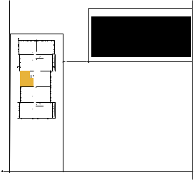

Plans and specifications are subject to change without notice. Actual usable floor space may vary from stated floor area. Illustrations are artists concept only and may show optional features not included in base price.
See sales representative for further information. E. & O. E.

GLEBE ST

Ï

NORTH TOWER1

GASLIGHT

SQUARE

FRASER ST

GRAND AVE

FLOOR 19-20

 |  |  |  |  |  |  |  |  | 2A
 |  |  |  |  |  |  |  |  | T H E
 |  |  |  |  |  |  | LANGDON
 |  |  | BEDROOM |  |  |  |  |  | T W O
 |  |  | 12'-5" X 10'-2" |  |  |  |  |  | T W O
 |  |  |  |  |  |  |  |  | BEDROOM
 |  |  |  |  |  | EP
 |  |  |  |  |  |  |  |  | SUITE:
 |  |  |  |  |  |  |  |  | 1126 SQ.FT.
 |  |  |  |  |  |  |  |  | BALCONY:
 |  |  |  |  |  |  |  |  | 195 SQ.FT.
 |  |  |  |  |  | W/D |  |  | 945 SQ.FT. TERRACE
 |  |  |  |  |  |  |  |  | ON FLOOR 6
 |  |  |  |  |  |  |  |  | TOTAL AREA:
 |  |  | KITCHEN |  |  |  |  |  | 1321 SQ.FT.
 |  |  | 17'-0" X 9'-0"
 |  |  |  |  |  |  |  |  | FLOORS
 |  |  |  |  |  |  |  |  | 6 THROUGH 20
 | BALCONY
 |  | 8'-1” | 8'-11"
 |  | DINING | 15'-2" | LIVING
 |  |  |  |  |  | BEDROOM
 |  |  |  |  |  | 11'-3" X 10'-2"
 | Ï |  | Ï |  |  | Ï |  |  | Plans and specifications are
 | NORTH |  | NORTH |  |  | NORTH |  |  | subject to change without
 | TOWER 1 |  |  | TOWER 1 |  | TOWER 1 |  |  | subject to change without
 | TOWER 1 |  |  | TOWER 1 |  | TOWER 1 |  |  | notice. Actual usable floor
GLEBE ST |  | GRAND AVE | GLEBE ST |  | GRAND AVE |  |  | GRAND AVE | space may vary from stated
GLEBE ST |  | GRAND AVE | GLEBE ST |  | GRAND AVE |  |  | GRAND AVE | floor area. Illustrations are
GLEBE ST | GASLIGHT | GRAND AVE | GLEBE ST | GASLIGHT | GRAND AVE | GASLIGHT |  | GRAND AVE | artists concept only and may
GLEBE ST | SQUARE | GRAND AVE | GLEBE ST | SQUARE | GRAND AVE | GLEBEST |  | GRAND AVE | show optional features not
 | SQUARE |  |  | SQUARE |  | SQUARE |  |  | show optional features not
 |  |  |  |  |  |  |  |  | included in base price.
 |  |  |  |  |  |  |  |  | See sales representative for
 | FRASER ST |  |  | FRASER ST |  | FRASER ST |  |  | further information. E. & O. E.
 | FLOOR 6 |  | FLOOR 7-18 |  |  | FLOOR 19-20
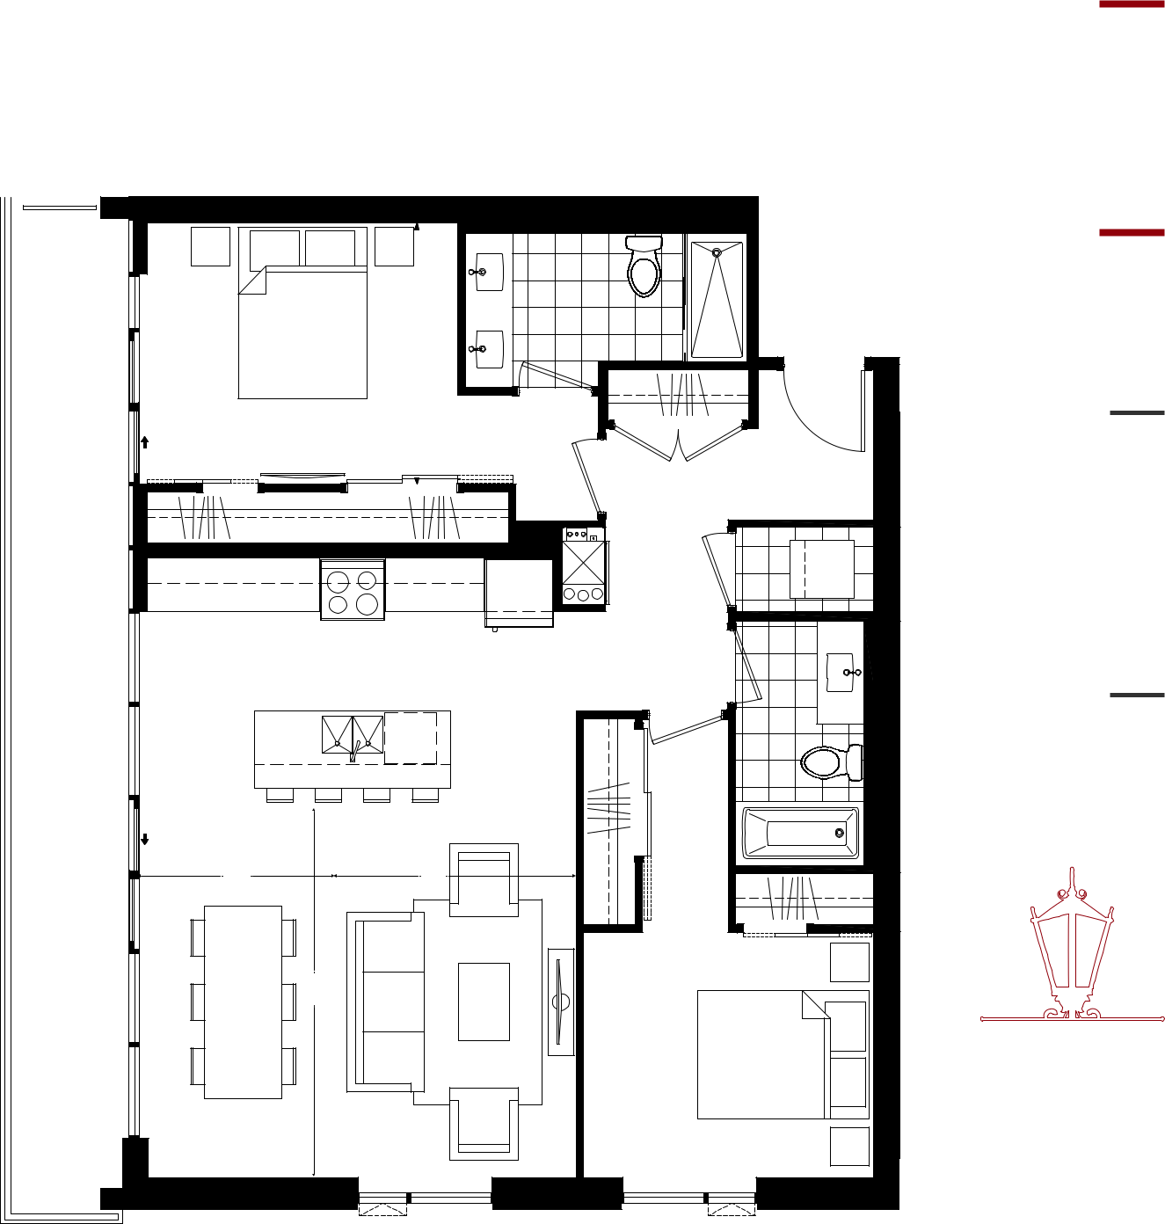
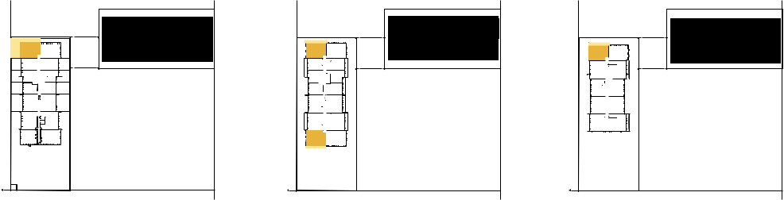
2B

T H E

MCCULLOCH
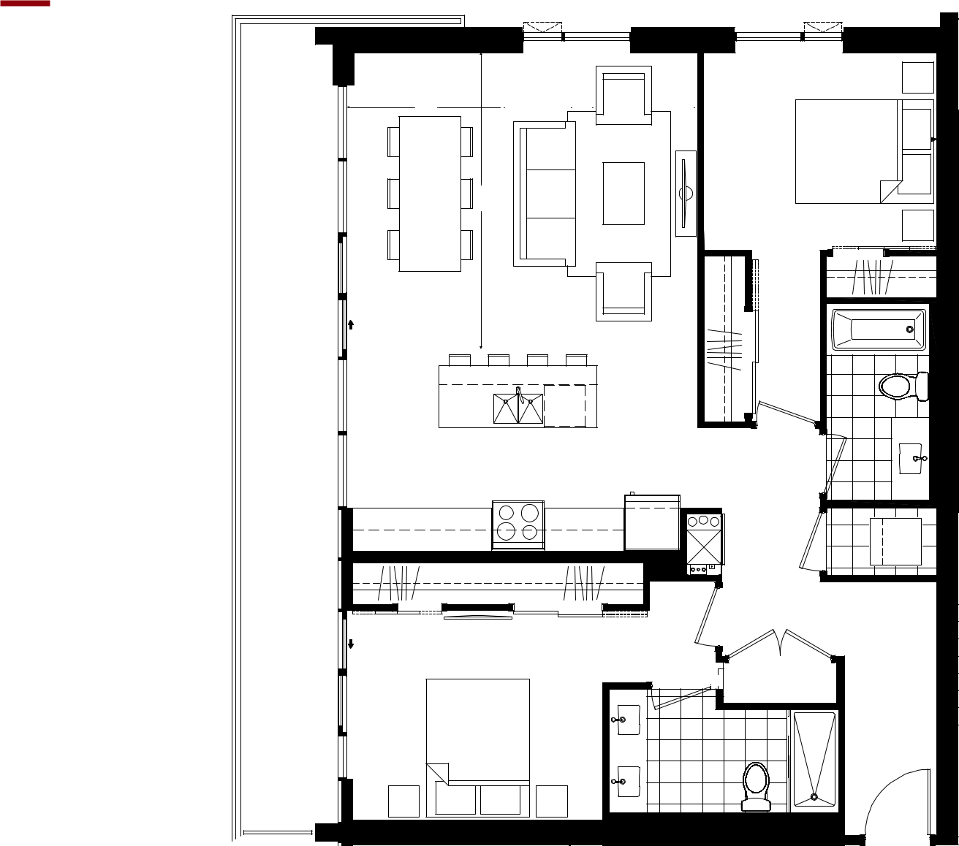

T W O

BEDROOM

SUITE:

1165 SQ.FT.

BALCONY:

195 SQ.FT.

945 SQ.FT. TERRACE ON FLOOR 6

TOTAL AREA:

1360 SQ.FT.

FLOORS

6 THROUGH 20

BALCONY

8'-1"

DINING

15'-2"

8'-11"

LIVING

KITCHEN

17'-0" X 9'-0"

BEDROOM

11'-3" X 10'-2"

W/D

EP
BEDROOM

12'-5" X 10'-2"
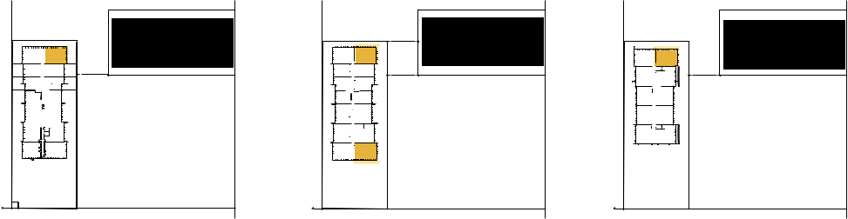

Plans and specifications are subject to change without notice. Actual usable floor space may vary from stated floor area. Illustrations are artists concept only and may show optional features not included in base price.
See sales representative for further information. E. & O. E.

Ï

NORTH

TOWER1

STGLEBE  GASLIGHT

SQUARE

FRASER ST

FLOOR 6

 |  | Ï
 |  | NORTH
 |  | TOWER 1
GRANDAVE | GLEBE ST | GASLIGHT | GRANDAVE | GLEBE ST
 |  | SQUARE
 |  | FRASER ST
 |  | FLOOR 7-18

Ï

NORTH TOWER1

GASLIGHT

SQUARE

FRASER ST

FLOOR 19-20

GRAND AVE

 |  |  |  |  | 2E
 |  |  |  |  | T H E
 |  |  |  | VICTORIA
 |  |  |  |  | T W O
 |  |  | KITCHEN/ |  | BEDROOM
 |  |  | DINING
 |  |  |  |  | SUITE:
 |  |  | -1" |  | 1045 SQ.FT.
 |  |  | 14'
 |  | W/D | OPTIONAL |  | BALCONY:
 |  | W/D | OPTIONAL |  | 164 SQ.FT.
 |  |  | ISLAND |  | 164 SQ.FT.
 |  |  |  |  | TOTAL AREA:
 |  |  |  |  | 1209 SQ.FT.
 | EP |  |  |  | FLOORS
 | EP | LINEN |  |  | 7 THROUGH 18
BEDROOM |  | BEDROOM | LIVING
BEDROOM |  | BEDROOM | 12'-0" X 16'-0"
10'-0" X 13'-11" |  | 10'-0" X 11'-8"
 |  | BALCONY
 |  |  | Ï |  | Plans and specifications are
 |  |  | NORTH |  | subject to change without
 |  |  | TOWER 1 |  | subject to change without
 |  |  | TOWER 1 |  | notice. Actual usable floor
 |  |  |  | GRAND AVE | space may vary from stated
 |  |  |  | GRAND AVE | floor area. Illustrations are
 |  |  | GASLIGHT | GRAND AVE | artists concept only and may
 |  |  | GLEBEST | GRAND AVE | show optional features not
 |  |  | SQUARE |  | show optional features not
 |  |  |  |  | included in base price.
 |  |  |  |  | See sales representative for
 |  |  | FRASER ST |  | further information. E. & O. E.
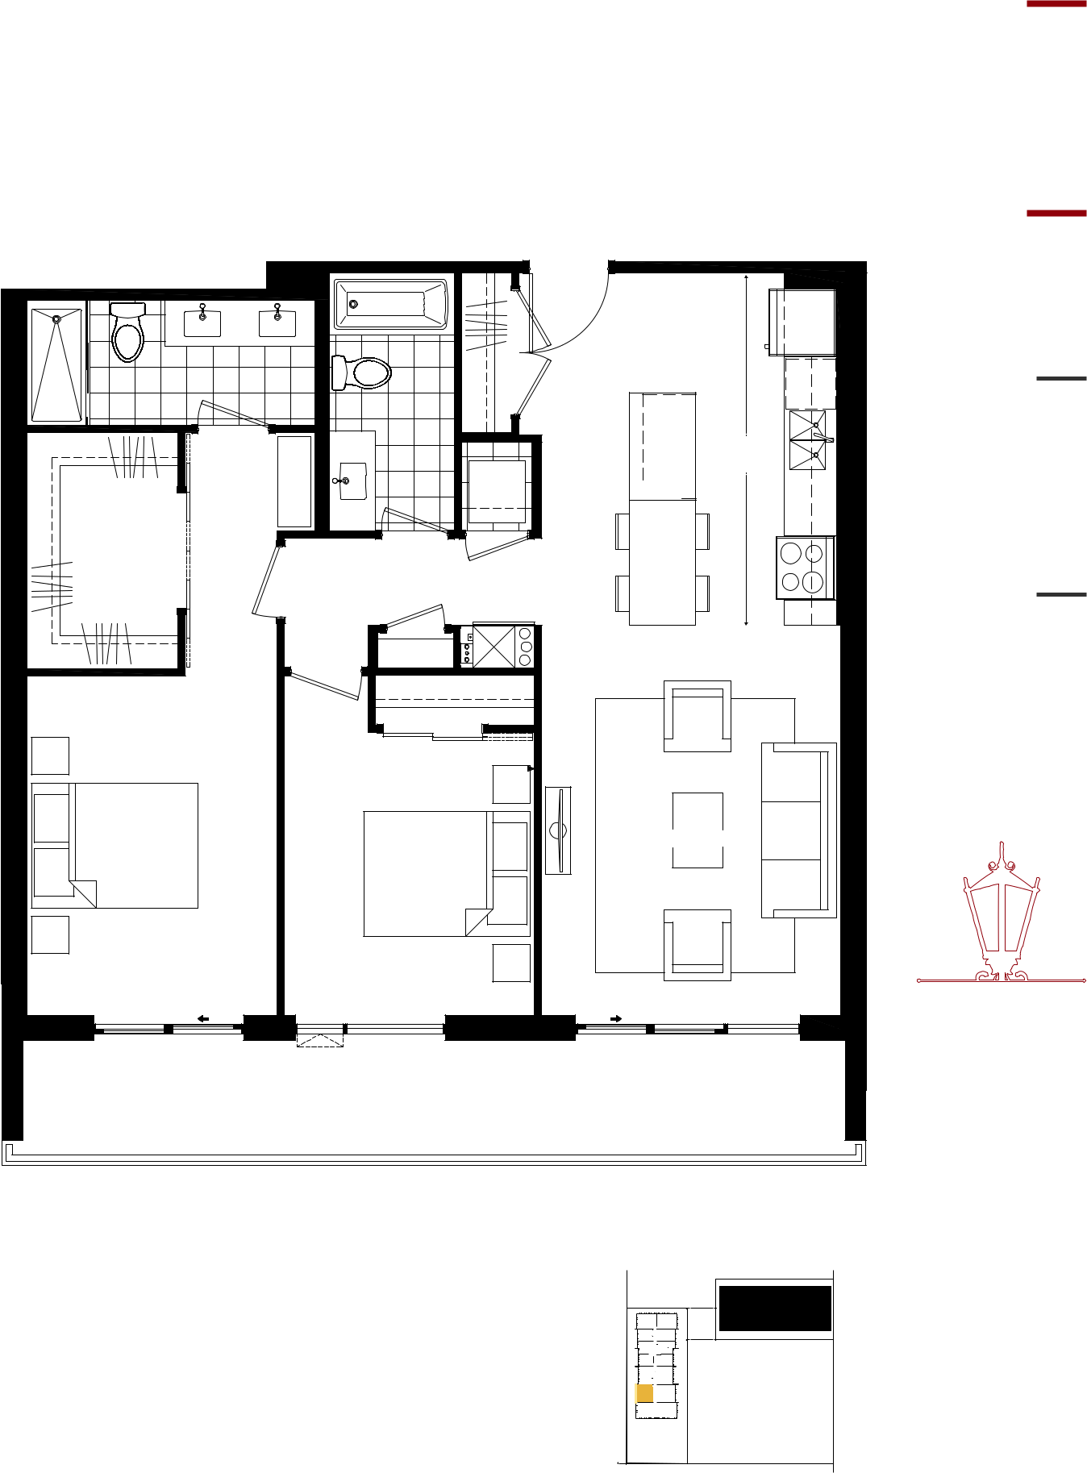

FLOOR 7-18

PENTHOUSE COLLECTION / 2G

 |  |  |  |  | T H E
 |  |  |  |  | RIVER
 |  |  |  |  | T W O
 |  |  |  |  | BEDROOM
 |  | KITCHEN
 | 11'-3" |  |  |  | SUITE:
 |  |  |  |  | 1115 SQ.FT.
 | COMM |  |  |  | BALCONY:
 |  |  |  |  | 176 SQ.FT.
W/D |  |  |  |  | TOTAL AREA:
 |  |  |  |  | 1291 SQ.FT.
 | EP
 | -3" | DINING
 | 6'
 |  |  |  |  | FLOORS
 |  |  |  |  | 19 THROUGH 20
 |  | 13'-11"
BEDROOM | 12'-8" |  | BEDROOM
BEDROOM |  | LIVING | BEDROOM
10'-0" X 10'-10" |  | LIVING | 10'-4" X 15'-0"
 |  | BALCONY
 |  | Ï |  |  | Plans and specifications are
 |  | NORTH |  |  | subject to change without
 |  |  | TOWER 1 |  | subject to change without
 |  |  | TOWER 1 |  | notice. Actual usable floor
 |  | GLEBE ST |  | GRAND AVE | space may vary from stated
 |  | GLEBE ST |  | GRAND AVE | floor area. Illustrations are
 |  | GLEBE ST | GASLIGHT | GRAND AVE | artists concept only and may
 |  | GLEBE ST | GASLIGHT | GRAND AVE | show optional features not
 |  | GLEBE ST | SQUARE | GRAND AVE | show optional features not
 |  |  |  |  | included in base price.
 |  |  |  |  | See sales representative for
 |  |  | FRASER ST |  | further information. E. & O. E.
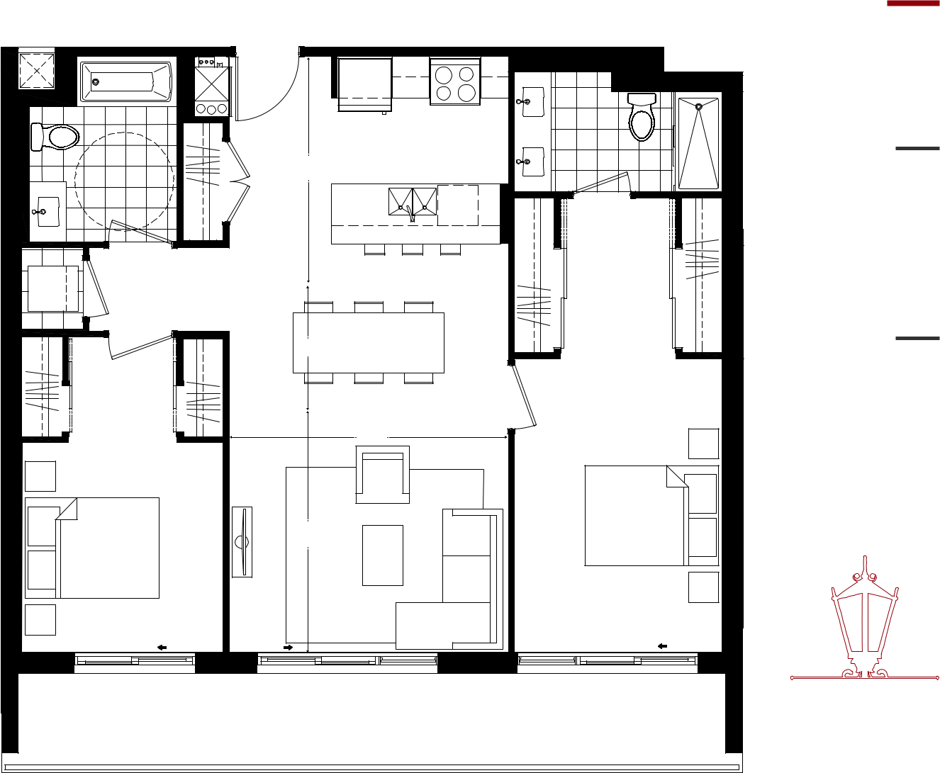
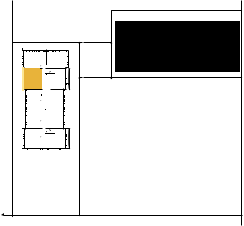

FLOOR 19-20

PENTHOUSE COLLECTION / 2J

T H E

WATER

T W O

BEDROOM
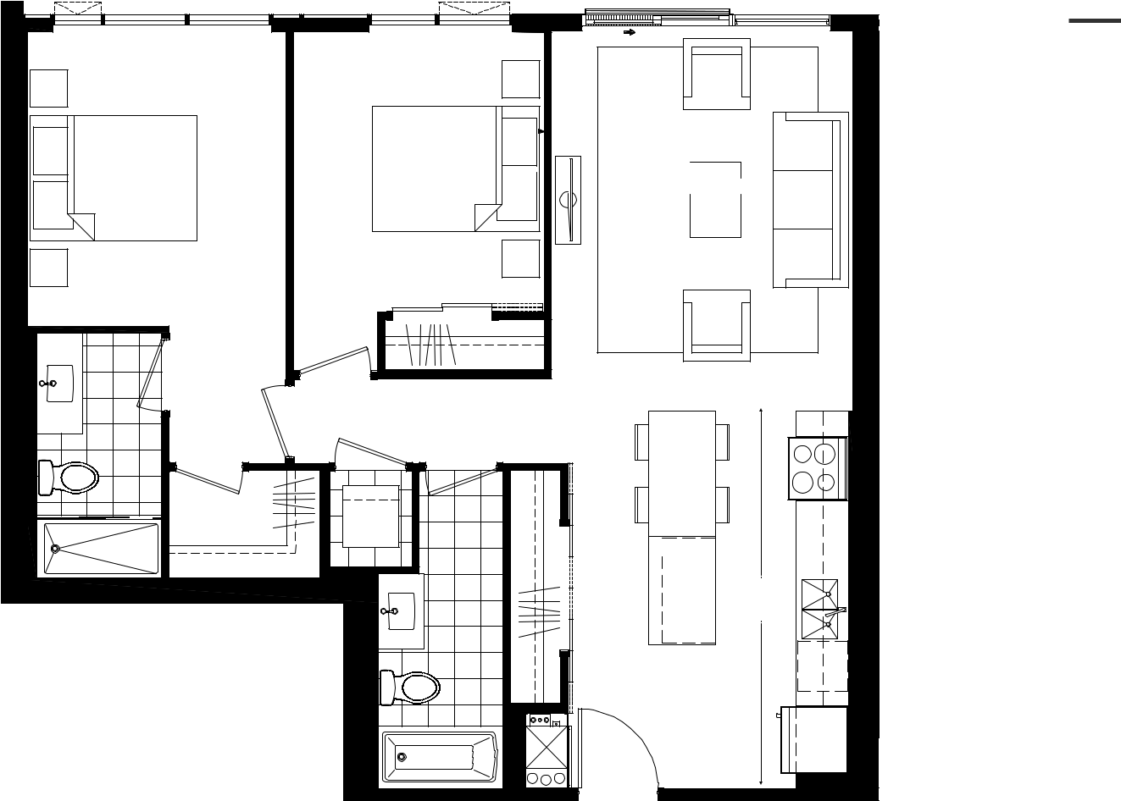

BEDROOM BEDROOM LIVING
10'-4" X 12'-0" 10'-0" X 11'-6" 12'-0" X 15'-5"

EP

W/D

OPTIONAL

ISLAND

1"-15'

KITCHEN/

DINING
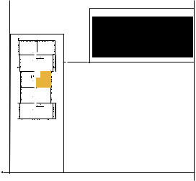

Ï

NORTH

TOWER1

GLEBE ST | GASLIGHT | GRANDAVE
 | SQUARE
 | FRASER ST

SUITE: 968 SQ.FT.

FLOORS 19 THROUGH 20

Plans and specifications are subject to change without notice. Actual usable floor space may vary from stated floor area. Illustrations are artists concept only and may show optional features not included in base price.
See sales representative for further information. E. & O. E.

FLOOR 19-20

